Table of Contents
1 Goal 3
2 Current Materials 3
3 Overall System 3
4 Use Cosmic Watch to construct and test particle detector 3
5 Circuit Design 4
6 Radio Hardware and Protocol Design 7
6.1 APRS Radio System (1200bps) 7
6.2 Radio Modem (115200bps) 8
6.3 UAV Data Link (2.8Mbps) 8
6.4 Conclusion 8
7 Particle Detector and Wireless Transmission Hardware Designs 8
7.1 Signal through ADC Pin 8
7.2 Signal through I²C Pins 8
7.3 Conclusion 8
7.4 Modification Plan 8
8 VHF Antenna 9
9 Power Supply Design 10
9.1 Lithium-ion Battery 10
9.2 Lithium Polymer Battery 10
9.3 Alkaline battery 10
9.4 Supercapacitor 10
9.5 Solar Panel 10
9.6 Conclusion 10
9.7 Predicted Capacity 10
10 HAB collection and Recovery 12
10.1 Balloon + Parachute 12
10.2 Ascending Balloon + Parachute + Descending Balloon 13
10.3 Horizontal Adjustments 13
11 Design and Manufacture Encapsulation 14
11.1 Possible Designs 14
11.2 Conclusion 15
12 Test 15
12.1 Current Questions 15
13 Launch 15
14 References 15

Goal
Cosmic rays and muons produced in the upper atmosphere constantly rain down on the surface of the Earth. Here we propose to measure the flux (number of muons per unit area per second) as a function of altitude. The goal is to design a high-altitude air balloon systems that will be used to measure the flux of cosmic ray muons from the ground to an altitude of 20km. The HAB should be deployable, trackable, and recoverable.
Use silicon photomultipliers (SiPMs) to construct a low-mass detector that is simple, inexpensive, and robust. Data acquired by the detector and balloon tracking data will be transmitted to the ground and will be logged on board the balloon. The data thus acquired will be used to confirm the phenomenon of dilation predicted by Einstein’s Special Theory of Relativity and to test models of cosmic ray production in the stratosphere.

Current Materials
- Purchased four plastic scintillators, which are expected to arrive in late February.
- Purchased SiPM and a set of CosmicWatch PCB and related parts. Although CosmicWatch might not be the most ideal payload, it can be used to test the scintillation detectors in the early stages.

Overall System
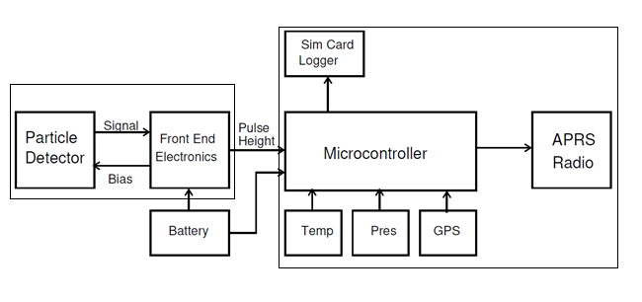
Figure 3-1 Diagram of the system components
There is a general concept of the particle detector payload, but the specific designs are still being worked out as there are a few possibilities. The production and integration process of the HAB system is also being worked on.

Use Cosmic Watch to construct and test particle detector
- Consider resources in http://www.cosmicwatch.lns.mit.edu/ and https://github.com/spenceraxani/CosmicWatch-Desktop-Muon-Detector-v2
- Analyze how Cosmic Watch is implemented, especially how the particle detector produces, collects, processes, and stores the signals.
- determine the tracking design.

Circuit Design
P1-2 of the SiPM electrical circuit takes a 29.5V current, P3-4 is to ground, and P5-6 outputs to Cosmic Watch Main PCB.
Figure 5-1 Cosmic Watch Circuit Diagram
The SiPM DC-DC power supply circuit uses LT2461 to construct a DC-DC booster to boost the source 4.6V DC to a 29.5V for the SiPM electrical circuits.
Figure 5-2 Booster in SiPM
With the LT1807 dual operational amplifiers, signals collected by SiPM goes through amplification and peak detection. The signal is then sent to ADC port of the MCU to be converted into a digital signal to be displayed, stored, and outputted.
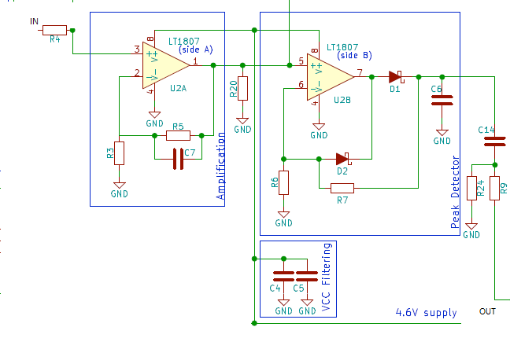
Figure 5-3 Main PCB of SiPM
The MCU Cosmic Watch uses is the Arduino Nano, and the peak signal is send to the ADC [0] pin.
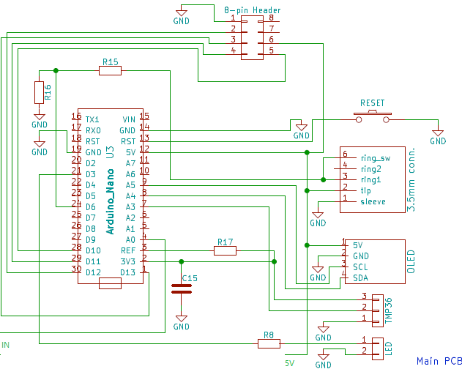
Figure 5-4 Arduino Nano Circuit Diagram
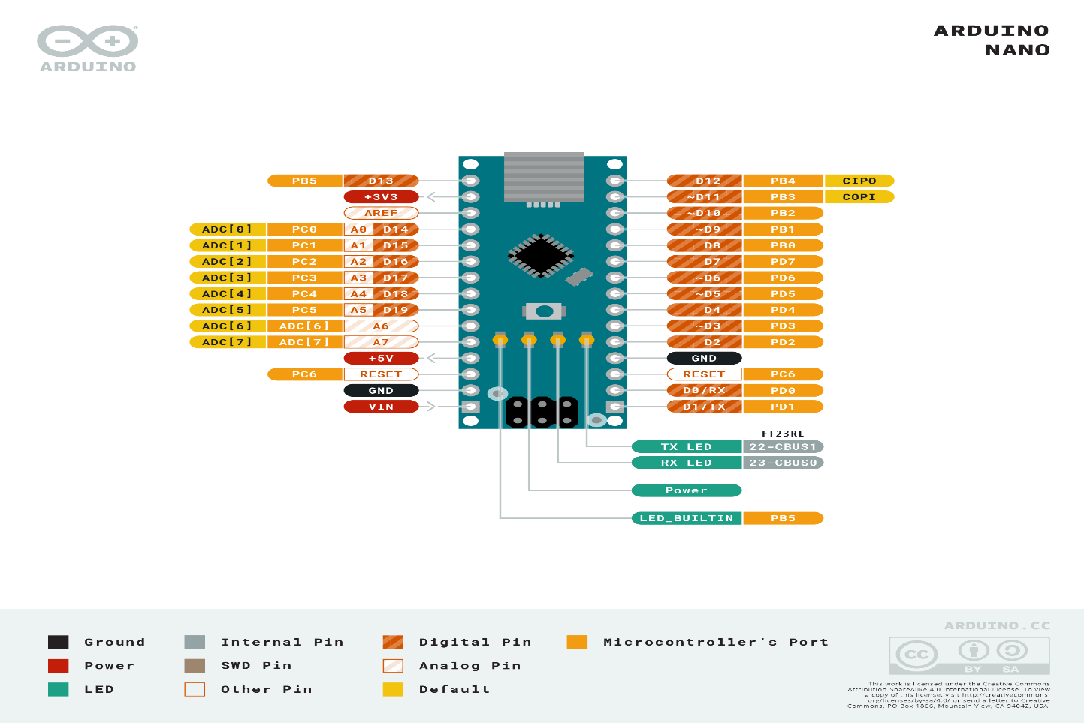
Figure 5-5 Arduino Nano IO Diagram
Data collected by Cosmic Watch is then stored in the SD card on the microSD PCB. The PCB is connected to the main MCU with an 8-pin connector. The MCU uses SPI pin to read from and write to the SD card. The 3.3V stable current circuit constructed with AP2138N on the microSD PCB is used to power the SD card. HC4050 provides a buffer for the read, write, and clock from the MCU. Looking at the diagram, the design of this PCB is not logical. First, HC4050 takes a 4.6V current, which means that the max output of which is also 4.6V, exceeding the 3.3V limit of the SD card.
Figure 5-6 Circuit Diagram of the SD card reader
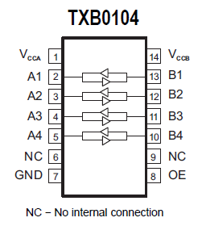
Also, since HC4050 is a one-directional buffer, D0 does not go through the buffer. This means that the buffer circuit does not improve the anti-EMI (anti-electromagnetic interference) capability of the SD card reader. It is suggested to replace this with a bidirectional buffer chip, such as the TXB0104 from Ti. This is a “4-Bit Bidirectional Voltage-Level Translator with Automatic Direction Sensing and ±15-kV ESD Protection.”
Figure 5-7 Digram of HC4050 vs Diagram of TXB0104

Radio Hardware and Protocol Design

APRS Radio System (1200bps)
Consider http://qrp-labs.com/lightaprs and https://github.com/lightaprs/LightAPRS-1.0
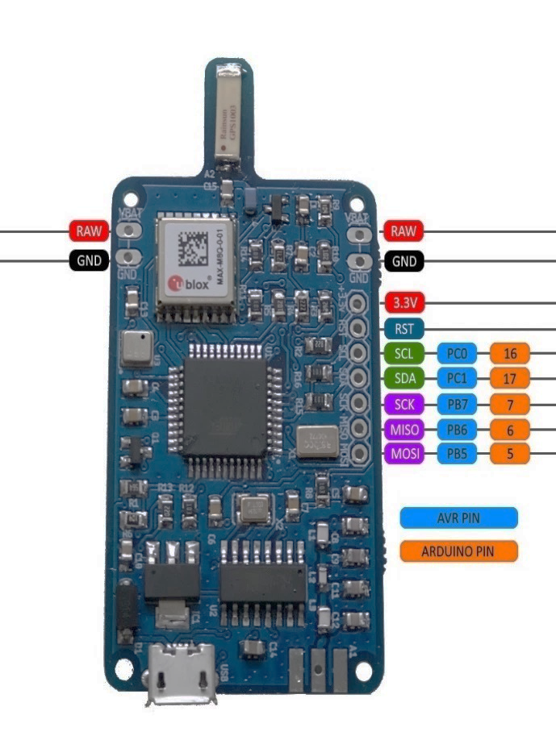
Software: Open Source
Weight: 9 grams
Dimensions： 3.5 cm x 6 cm
IDE: Arduino
Platform: MightyCore
CPU: Atmega1284P-AU
Flash: 128 kB
Ram: 16 kB
EEPROM: 4 kB
Operating Frequency: 8 MHz
Operating Voltage: 3.3 Volt
Input Voltage: 4.5 (min) - 10 (max) Volt via usb or VBat pin
BOD: 2.7 Volt
Sensor: BMP180 (pressure and temperature)
VHF Radio Module: Dorji DRA818V (included)
VHF Radio Operating Frequency: 144-146 Mhz (configurable by code)
Figure 6-1 APRS Board
VHF Low Pass Filter: Available (7 elements)
VHF Radio Power: 0.5 Watt or 1 Watt (configurable by code)
VHF Power Consumption (TX): ~460 mA (0.5 Watt) / ~760 mA (1 Watt) (Automatically selected based on input voltage by code)
HF Radio Module: Si5351A-B-GT (included)
HF Radio Operating Frequency: 2.5kHz - 200Mhz (configurable by code)
HF Low Pass Filter: No

Radio Modem (115200bps)
Models like GEMDS EL-806 have a theoretical transmission distance of 15km, but the actual distance is unknown (GE MDS).

UAV Data Link (2.8Mbps)
These devices, such as DJI Lightbridge 2, have a short transmission distance of 5km, which is not suitable (DJI).

Conclusion
Taking reliability, transmission rate, weight, and cost into consideration, Radio APRS system is the most ideal design for this project.

Particle Detector and Wireless Transmission Hardware Designs

Signal through ADC Pin
The peak signal detected by the particle detector is directly sent to the wireless transmitter and then processed by an ADC converter to collect, store, and transmit the signal. This requires the wireless transmitter to have an ADC pin and the detector only needs to send an analog signal, and MCU is necessary. While the LightAPRS MCU chip ATmega1284 has 8 ADC pins (PF0-7), none was drawn out by the board.

Signal through I²C Pins
Since on LightAPRS, only the I²C and SPI pins have pads, the detector needs the MCU to collect the analog signal and send it through the I²C pins.

Conclusion
To simplify the circuit and reduce both weight and power consumption, redesigning the Front Electronics board to simplify (remove redundant functions) and connect directly to the APRS board is ideal.

Modification Plan
Since LightAPRS does not provide ADC breakout, we can use the RST pad. By cutting off the connection of the pad to the CPU Atmega1284, we can reconnect pin 37 (ADC0) from the Atmega1284 to the pad and keep SCK , MISO, MOSI pins for SPI to connect microSD reader.
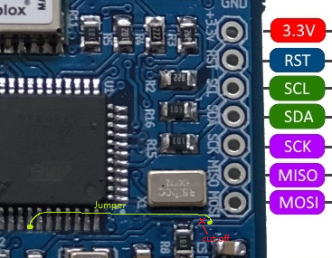
Figure 7-1 planned modifications to the APRS board
Then, the front PCB of the particle detector will also need to be redesigned.
Figure 7-2 Electrical Diagram of the new front board

VHF Antenna
According to FCC, frequency of APRS is 144.39Mhz. For simplicity’s sake, quarter wave monopole antenna is the best choice.
$$l_{antenna}=\frac{1}{4}×\frac{\frac{299792458m}{s}}{144.39MHz}=\frac{1}{4}×2.0763=0.51907m=51.907cm$$
Thus, taking a copper wire of length 51.91cm and solder it onto the middle pad of A1.
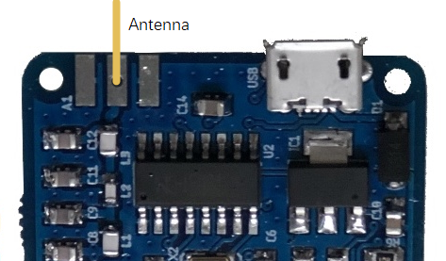
Figure 8-1 Position of the antenna

Power Supply Design

Lithium-ion Battery
Have High energy density and multiple configurations of voltage, but functions poorly in cold temperatures and charges slowly.

Lithium Polymer Battery
Since li-po uses a solid, gel-like electrolyte, it is more robust and can withstand harsher weather conditions. However, it is less energy dense and more costly.

Alkaline battery
Has lower energy density than lithium batteries and is single use. Has even worse low-temperature performance.

Supercapacitor
Good low-temperature performance and changes quickly, but is large

Solar Panel
Accessible energy than can be collected while HAB is in the air but cannot provide stable current and is prone to changes in weather.

Conclusion
Lithium-ion is the more ideal design. The capacity needs to be determined by the consumption of the detectors and APRS, the transmission frequency (per second or per minute) and the time it takes for the HAB to rise to the designated altitude (15-20km).

Predicted Capacity
$$P_{SiPM}=29.5V×20mA=590mW$$
$$P_{LT1807}=2×5V×13mA=130mW$$
The standby current for the SD card is 950μA and the average operation current is 200mA. Assume that SD card is on 50% of the time
$$P_{MicroSD}=\frac{1}{2}×3.3V×\left(200mA+950μA\right)=332mW$$
The Power consumption of the VHF is 760mA 1W. Assume that it is on 20% of the time (twice per minute)
$$P_{VHF}=\frac{1}{5}×5V×760mA=502mW$$
$$P_{ATmega1284}=5V×11mA=55mW$$
$$P_{Ublox MAX-M8Q}=5V×23mA=115mW$$
$$P_{CH340}=5V×20mA=100mW$$
$$P_{Other}=5V×5mA=25mW$$
$$P_{LightAPRS}=502mW+55mW+115mW+100mW+25mW=797mW$$
$$P_{Total}=590mW+130mW+332mW+797mW=1849mW$$
Take the voltage conversion loss into consideration, and assume the efficiency to be 80%, the total power needed is
$$P_{Battery}=\frac{1849mW}{80\%}=2.3W$$
With http://tools.highaltitudescience.com/ I can calculate the time it takes for the HAB to rise. Assume the flight duration to be 3 hours, and double the amount of extra, taking into consideration of time to find payload once landed and the efficiency of the battery, the entire trip will be 9 hours. Costing a total of
$$E_{Battery}=2.3W×9h=20.7Wh$$
If we use 5V battery packs, the capacity will need to be
$$Q_{5V}=\frac{20.7Wh}{5V}=4.14Ah=4140mAh$$
If we use 3.6V battery packs, the capacity will be
$$Q_{3.3V}=\frac{20.7Wh}{3.6V}=5.75Ah=5750mAh$$

HAB collection and Recovery

Balloon + Parachute
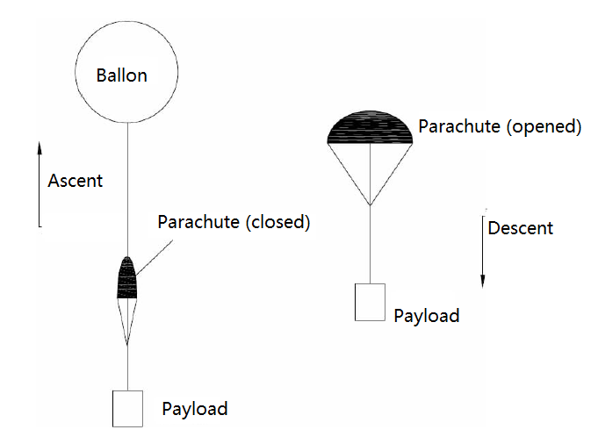
Figure 10-1 Design of the parachute

Ascending Balloon + Parachute + Descending Balloon
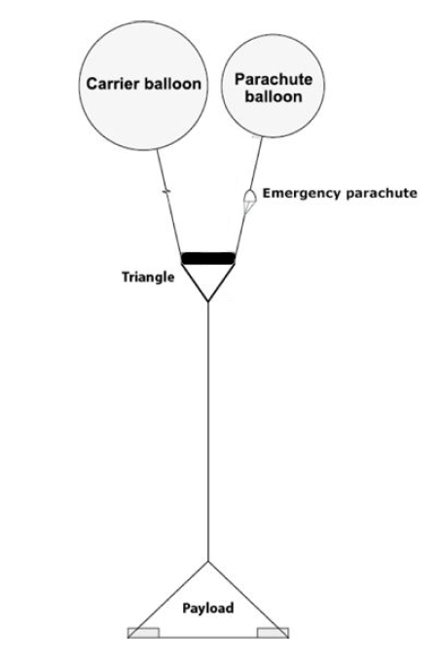
Figure 10-2 After the carrier balloon pops, the parachute balloon will decrease the downward acceleration while the payload falls

Horizontal Adjustments
Adding a propeller and a servo (used to change direction of propeller) to the base of the HAB. To connect for orientation, would it also be logical to add an electrical compass?
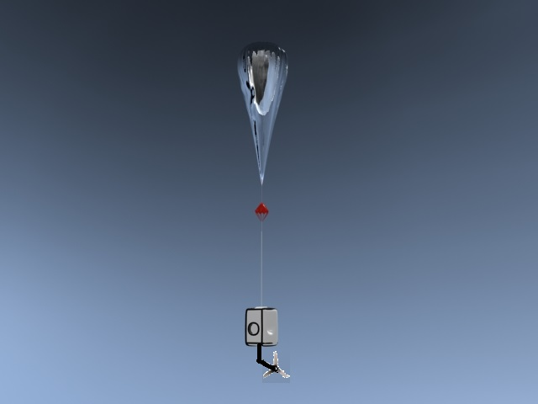
Figure 10-3 Potential Propeller Design

Design and Manufacture Encapsulation
Due to the low environmental temperature of the system (-55°C), the lowest working temperature of each component of the system (including batteries) must be considered. The chips only function >40°C and the battery only functions >0°C. Thus, thermal insulation and heating is needed.
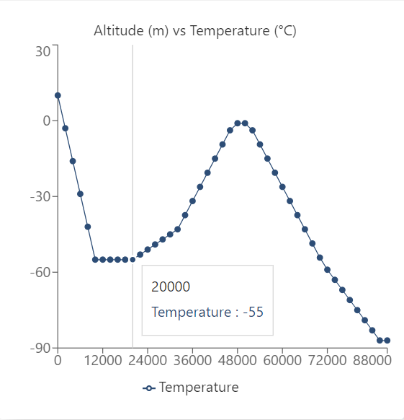
Figure 11-1 Temperature of the environment as altitude increases

Possible Designs
- Insulation Material
- Electric heating + insulation
- Chemical heating + insulation

Conclusion
After consulting some references, just the insulation material should be enough keeping the temperature relatively high. The material chosen is polystyrene foam.

Test
It is hard to design the tests for the HAB system due to the low working temperature and the lack of access to how APRS system works.

Current Questions
- How to test?
- How to receive the signals? Radio?
- Decoder board?
- How to connect to host?

System Mass
Plastic scintillator:
$$V_{sci}=5cm×5cm×1cm$$
$$ρ_{sci}=\frac{1.032g}{{cm}^{3}}$$
$$m_{sci}=5cm×5cm×1cm×\frac{1.032g}{{cm}^{3}}=25.8g$$
Outer cylindrical shell:
$$Δr=0.3cm$$
$$\overline{r}=5cm$$
$$h=15cm$$
$$V_{shell}=2π×5cm×\left(15cm-2×0.3cm\right)×0.3cm+2π×{\left(5cm+\frac{0.3cm}{2}\right)}^{2}×0.3cm=186{cm}^{3}$$
$$ρ_{sci}=\frac{1.43g}{{cm}^{3}}$$
$$m_{sci}=186{cm}^{3}×\frac{1.43g}{{cm}^{3}}=266g$$

Component | Mass
Plastic scintillator | 25.8g
SiPM PCB | 10g
Particle Detector Front Board | 10g
LightAPRS | 9g
Antenna | 5g
microSD PCB | 5g
Battery (3.6V/6000mAh) | 100g
Insulation | 20g
Shell | 266g
Total: | 446g

Launch
Balloon selection should consult Understanding High-Altitude Balloon Flight Fundamentals and launch location, weather, and landing prediction should consult High Altitude Balloon Flight Predictions (Voss, Ramm and Dailey) (Stafford). Tool written for NOAA balloon flight predictions is available from: https://www.ready.noaa.gov/READY_balloon.php

References
DJI. "DJI Lightbridge 2 User Manual V1.6." 20 Feburary 2017. DJI. PDF File. 20 December 2022. <https://dl.djicdn.com/downloads/lightbridge2/20170217/DJI+Lightbridge+2+User+Manual+V1.6.pdf>.
GE MDS. "GE MDS TransNET OEM EL806 Manuals." June 2007. manualslib. PDF File. 25 December 2022. <https://www.manualslib.com/products/Ge-Mds-Transnet-Oem-El806-9236134.html>.
Stafford, Sara. "High Altitude Balloon Flight Predictions." n.d. PDF File.
Voss, D. Voss, Natalie A. Ramm and Jeff Dailey. "Understanding High-Altitude Balloon Flight Fundamentals." Academic High-Altitude Conference. Indiana, 2012. 74-83. PDF File.

